PROGRAMME SCHEDULE
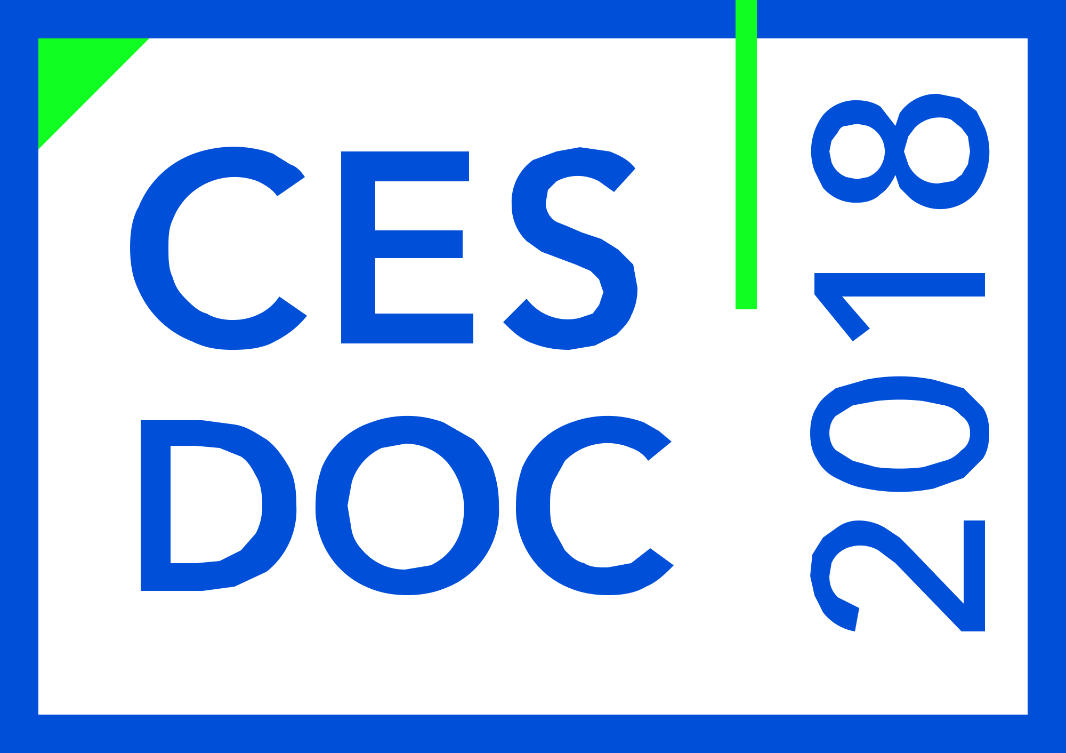 | Day 1  18th December 2018  Tuesday
TIME | ACTIVITY |  | VENUE
08.30 – 09.30 | Registration |  | Registration Desk
09.30 – 10.30 | Inaugural Function |  | College Auditorium
10.30 – 11.00 | High Tea
 | Keynote Presentation | TOPIC | Chair:
11.00 – 11.30 | Prof. Dominik H. Lang | Monitoring the built environment –Towards more efficient Disaster Risk Reduction | College Auditorium
11.30 – 12.00 | Prof. Sajal. K. Deb | Seismic response control of low-rise buildings using U-STI: a low-cost base isolation system | College Auditorium
12.00 – 12.30 | Prof. B. Bhattacharjee | Durability for sustainable concrete in North-East India | College Auditorium
12.30 – 13.00 | Mr. Biswajit Das | Sustainable development of water resources in view of emerging challenges in India | College Auditorium
13.00 – 13.30 | Dr. Hemanta Doloi | Evaluating infrastructure projects through the lens of sustainability | College Auditorium
13.30 – 14.30 | Lunch Break |  | College Lawn
14.30 – 16.00 | Technical Session 1 |  | College Auditorium
 | Technical Session 2 |  | Room No. 2
 | Technical Session 3 |  | Seminar Room
16.00 – 17.30 | Technical Session 4 |  | College Auditorium
 | Technical Session 5 |  | Room No. 2
 | Technical Session 6 |  | Seminar Room
17.30 – 18.00 | Break
18.00 – 21.00 | Visit Stalls, Cultural Function and Conference Dinner | College Lawn

PROGRAMME SCHEDULE
Day 2
19th December 2018
Wednesday

TIME | ACTIVITY |  | VENUE
09.00 – 09.30 | Breakfast
 | Keynote presentation | TOPIC | Chair:
09.30 – 10.00 | Dr. Abdelghani Meslem | Recent Efforts Toward Earthquake Risk Reduction in India. | College Auditorium
10.00 – 10.30 | Dr. Shailesh Kr. Agarwal | Emerging construction systems for sustainable mass housing. | College Auditorium
10.30 – 11.00 | Dr. Manoj Datta | Sustainability of Landfills for Hazardous Waste and Municipal Solid Waste – Some Case Studies | College Auditorium
11.00 – 11.30 | Dr. I. K. Pateriya | Initiatives in research and new technologies application under PMGSY | College Auditorium
11.30 – 12.00 | Dr. Diganta Barman | Space based technology paradigm in flood management - an overview. | College Auditorium
12.00 – 12.30 | Dr. Kamal C. Sarma | Infrastructure development & our attitudes are two key elements for sustainable development of Assam. | College Auditorium
12.30 – 13.00 | Dr. Guna Nidhi Paudyal |  | College Auditorium
13.00 – 14.00 | Lunch Break |  | College Lawn
14.00 – 16.00 | Technical Session 7 |  | College Auditorium
 | Technical Session 8 |  | Room No. 2
 | Technical Session 9 |  | Seminar Room
16.00 – 16.15 | Break
16.15 – 17.00 | Plenary Session |  | College Auditorium
17.00 – 17.30 | Valedictory Function |  | College Auditorium

